

**COMSATS University Islamabad (CUI)**

Project Proposal   
(SCOPE DOCUMENT)

For

**Children Vaccination and Growth Tracking System**  
Version 1.0

***By***

**Shariq Ahmed CIIT/SP18-BCS-151/ISB**

**Umar Khalid CIIT/SP18-BCS-164/ISB**

***Supervisor*Dr. Ashfaq Hussain Farooqi**

*Bachelor of Science in Computer Science (2017-2021)*

**SCOPE DOCUMENT REVISION HISTORY**

|  |  |  |
| --- | --- | --- |
| **No.** | **Comment** | **Action** |
|  |  |  |
|  |  |  |
|  |  |  |
|  |  |  |
|  |  |  |
|  |  |  |

**Supervisor Signature:**

**Date:**

Contents

Abstract i

1. Introduction ii

2. Problem Statement ii

3. Problem Solution for the Proposed System iii

1. Related System Analysis/Literature Review iv

2. Advantages/Benefits of Proposed System v

3. Project Scope v

Module 1: Child Record Management and Tracking vi

Module 2: Vaccine and Vaccine Center Management: vi

Module 3: User Management vi

Module 4: Predict Growth Tracking vi

Module 5: Decision Support System vii

4. System Limitations/Constraints vii

5. Software Process Methodology viii

6. Tools and Technologies viii

7. Project Stakeholders and Roles ix

8. Team Members Individual Tasks/Work Division ix

9. Data Gathering Approach ix

a. Observation ix

b. Research ix

c. Brainstorming x

d. Interview x

10. Concepts x

Artificial Intelligence: x

Database: x

11. Gantt chart xi

12. Mockups xii

13. Conclusion xv

References xv

14. Plagiarism Report xvii

**Table of tables**

Table 1:Related System Analysis with Targeted Project Solution. iv

Table 2:Tools and Technologies for Child Vaccination and Growth Tracking System. viii

Table 3:Project Stakeholders for the Targeted Project. ix

Table 4:Team Member Work Division the Targeted Project. ix

**Table of figures**

Figure 1: Gantt Chart xi

Figure 2: Hospital management mock xii

Figure 3: Admin Panel Mock xiii

Figure 4:Vaccination management mock xiv

Figure 5:Child Growth mock xiv

Figure 6: Data visual mock xv

Figure 7: Plagiarism Report xvii

**Project Category:**

Web Application



Problem Solving and Artificial Intelligence



 Smartphone Application

# Abstract

In this modern era of technology, it is need of the moment to automate existing manual immunization system as about 62 out of 1000 children dies every year [1] and half of this death are due to non-immunization of children. The current system cannot track those children which are not getting vaccinated. Neither in our country, the parent can track their child's growth.

This system is providing help to authorities and parents at the same time. This system will help authorities to track all the children who have to be vaccinated. Also, it will keep a record of the vaccine and its user. It will help authorities to monitor the polio workers and keep check of their duties. For parents, this system will help them to monitor their child's growth.

# Introduction

Pakistan is an underdeveloped country with numerous problems but thetop of them is not having basic health facilities. There is alack of hospitals, health centers, education**,** and responsibility. Pakistan is one of those countries which has thehighest infant and child mortality rate. Half of them are due to vaccine-preventable diseases. In 2019 mortality rate of children was 62 out of 1000[2]. These numbers are reducing with time. In 1970 themortality rate was 190 out of 1000. But still**,** we are unable to stop these deaths. Because we don’t have a proper system to monitor all the health**-**related issues. Pakistan has started its Expanded Program on immunization (EPI) in 1978 [3] but its result **is** not satisfactory. One of the major things is that we are one of the two countries where polio is not eradicated. Another is Afghanistan.

The government spends million**s** on polio and other vaccination campaigns but results are not much fruitful. The main problem which we have noted is that our vaccination system is not tracking infants from their birth. We have a manual system which consist**s** of a book. Another problem which we noted during our research is the lack of education in people. Many people think especially in the rural and backward areas where there is alack of education that these vaccines are not good for their children. Many religious extremists believe that these vaccines will create infertility problem**s** in the children so they don’t take their children to vaccination centers and even if the polio workers come, they lie to them**,** and in extreme cases especially in KPK, some polio workers got killed too for this reason.

Apart from the vaccination, another reason for thehigh mortality rate among children is lack of nutrition among them[4]. There is no proper monitoring of the child**'s** growth which leads them towards having diseases or in many cases these infants or children die too.

So we are proposing a model which covers both of these problems. This model will try to track the children and will tell the authorities about the infants and their parents’ details so the authorities can track them. This system will add all the details about infants, notify them before their vaccination dates, mark their presence or absence**,** and report of the absentees. This will be going to help the authorities to track the children and their parents so if anyone tries to escape they will be tracked easily. It will also predict which area could have more children with these diseases. Stats on **a** yearly and monthly bas**i**s will be generated to see how many children got thevaccine and how many were left. Child growth and vaccination tracking will also be done by thesystem.

# Problem Statement

All the developed countries have centralized health care system which helps them to track record of children and if someone is not getting his child vaccinated, he is penalized heavily. The reason being doing that is these are communicable diseases that can spread from one to others. These diseases include TB, Polio, Hepatitis, Flu, Measles**,** etc. To prevent these diseases to spread among others, immunization against them is done by thevaccine. As we know that Pakistan ha**s** poor health facilities and there is no proper infrastructure so no track of childbirth and their parent. And because of not having a centralized health care system it is difficult to track the children who are not getting thevaccination. Another thing is the manual system. People often forget the dates of vaccination of their children.

In many health care centers, there is ashortage of vaccine**s** sometimes. One more problem is that sometimes children get expired vaccine which cause**s** serious diseases and, in some cases, the child die**s** too. Apart from the vaccination**-**related problem, Pakistan is also facing achild undergrowth problem. Many children don’t grow properly in the initial years which cause**s** many deficiencies among them. Parents cannot monitor their child growth.

So this system will cover all these problems and assist the parents and authorities in reducing these communicable diseases and monitor the growth of children so that no child get**s** undergrowth diseases.

# 3. Problem Solution for the Proposed System

We have divided the system in**to** two different parts. One Is dealing with thevaccination system. It will add the infant and parents’ detail and will give vaccination dates to the parents. Then before the vaccination date**,** parents will be notified. If the child gets vaccinated then that vaccination will get marked and if h**e** is not vaccinated then thesystem will notify parents again. If thechild do**es**n’t get vaccinated then thereport will be delivered to authorities after two weeks. Also, thesystem will track all the details related to thevaccine. Its manufacturing and expiring dates, who is injecting that vaccine, how much stock is left etc. system will also predict the possible cases according to previous data. Apart from this system will also predict the requirement of thevaccine in the upcoming months.

Through this system**,** it will be easier to centralize all the data information and keep track of thehealth of newborn children. This system will be made in such a way that in thefuture if we want to centralize our country**'s** health care system then it will provide theroot system for the new system.

The other part of the system is dealing with parent**'**s benefits as parents can add the updated information of the child and mobile application**s** will tell them about their growth.

# Related System Analysis/Literature Review

Table 1: Related System Analysis with Targeted Project Solution.

|  |  |  |
| --- | --- | --- |
| **Application Name** | **Weakness** | **Proposed Project Solution** |
| Immunization information system [5] | * Limited to only tracking of vaccines * Not keeping track of individuals * Cannot predict about future vaccine requirement * Only US-based * Only web-based application | * The system will be able to track individuals too * It will keep all the record of vaccine and child too * It will be able to predict the future requirement of the vaccine in a specific area * The system will be able to generate all the reports which can help authorities * The system will be web and mobile-based * The system will also keep track of polio workers |
| Immunization exercise management system | * Only web-based application * Limited to only track the vaccine record * Don’t have prediction ability | * Track both child and vaccination record * Track the child growth * Mobile and web-based application * Can generate reports and statistical graphs |
| Child vaccination schedule | * User can only add a schedule and they will get the reminder * Only mobile application | * As mentioned about the system will automatically give a reminder to parents * Web and mobile applications will be made |
| Operability, Acceptability, and Usefulness of a Mobile App to Track Routine Immunization Performance in Rural Pakistan: Interview Study Among Vaccinators and Key Informants | * Only track record of people in rural areas * Not centralized * Only mobile application * Don’t keep a record of children whose vaccination is not done * Don’t keep a record of vaccinator and vaccine * Don’t have a good UI | * The system will be centralizing so it can be used in any area * It will keep a record of whether the child is vaccinated or not * It will keep track of the vaccinator so it will be easy if something wrong happens * The system will have a user-friendly UI |

# Advantages/Benefits of Proposed System

Following will be the benefits of our proposed system

* It will be centralized so it will make iteasy to track all the health record of thechild
* It will track all the record**s** of the children and their parents. So no one can escape from not doing immunization of their child
* It will track therecord of the vaccine and the vaccinator so there can be no shortage of vaccine in any health care center
* It will track the polio workers so if someone is not performing their duties then it will be easier to track them
* It will generate reports and statistical graphs that can help authorities to eradicate these diseases
* It will predict the possible cases and requirement**s** of thevaccine so it will help authorities too.
* It will help the parents to monitor their child**'s** growth.
* The **s**ystem will be in English and Urdu language so it will give benefit to those health worker**s** and parents too that are not good in English

# Project Scope

This system is trying to automate the existing immunization system with more features for authorities and parents. Following are the modules involved in our system

## Module 1: Child Record Management and Tracking

This module handles the children record and later track it. Hospital (sub admin) will add the data into the system at the time of birth. At this moment parent will be given 2 printable from the system that is birth certificate and schedule of vaccination. Apart from this, schedule will also be sent to parent on their provided mobile number. Later parents will get reminder before the vaccination dates. During vaccination, the system will confirm the status of vaccination through OTP. And then vaccination will be update. If child is not getting vaccinated, then parents will get remember messages and if they still not respond to it then the report will be sent to regional admin through this system

## Module 2: Vaccine and Vaccine Center Management:

This module is handling vaccines and Vaccine center related tasks. Vaccine center(sub-admin) can add or update the stocks. He can allot the stocks to hospitals and centers. They can also check the future requirements of the stock in a particular area and if needed they can request the stock from regional admin too

Other functionality of this module is to make the campaigns of vaccination and later monitor their performance or results. In this part, vaccination center will be able to notify the registered parents about the upcoming vaccine campaigns.

In this same module, polio vaccination is also managed. Regional admin will allot details of children to be vaccinated in a particular area and polio worker will visit and get this vaccination complete. Additionally, they will take some children information to check the possible case of the polio in the child through this. And if found, they will send report to regional admin on daily basis

## Module 3: User Management

This is a mobile based module which is going to be handled by end users i.e. Polio worker and parents. Our system will provide them the data of the children born in the allocated area. Polio worker will visit, and they will follow the same procedure of doing vaccination through our system.

Other part of this system is for the parents. This feature is providing record of their children through an app. In this application, they can view their children vaccination status. They can download vaccination completion certificate. Also, this feature will educate parents about vaccination through blogs and stats.

## Module 4: Predict Growth Tracking

In this module**,** parents will add their child information and thesystem will go through prediction model. This feature will take data of Children from 0-8 year. Upon their data submission, our system will predict the growth of their children. This data will be kept in the app and system will ask parents to update current information of child. Then on conclusion of previous record system will suggest specific diet and things which child has deficiency.

## Module 5: Decision Support System

This module will provide stats that will be shown to admin in the form of graph and numbers. These stats will be based on city, area, and province. These stats include how much children born, how much vaccinations used, how many children get vaccinated and how many were left.

Another feature of this module is the prediction of cases based on the past data. In this feature, system will use the present and past data of children and cases. And on the basis of these stats, system will predict future possible cases. These predictions will be based on cities and areas.

**Context Diagram:**

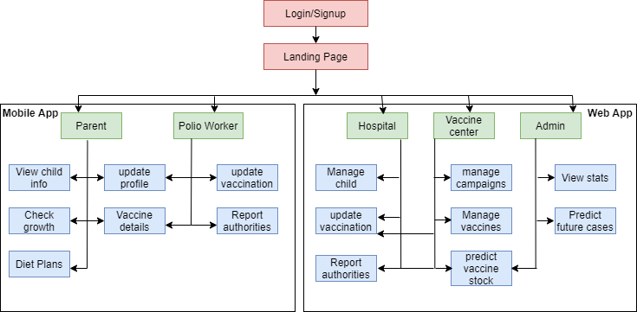

# System Limitations/Constraints

Limitations in the system are:

* The system cannot track polio workers using GPS.
* The system cannot track those children who are born at home
* The system cannot track those children’s vaccination record whose vaccination is done by a center which is not registered with us

# Software Process Methodology

We are going to use the incremental model in our project. Reasons for choosing an incremental model are

* Our project is long which consists of different modules
* Some modules can be implemented individually
* Requirements of the project are defined and won’t change during development
* So the incremental model suits our project as we can implement different modules and later we can develop and test them.
* In this way, the system will get a test in every possible way and we will get efficient results.

# Tools and Technologies

Following are the tools and technologies that will be used in making this system.

Table 2: Tools and Technologies for Child Vaccination and Growth Tracking System.

|  |  |  |  |
| --- | --- | --- | --- |
| **Tools**  **And**  **Technologies** | **Tools** | **Version** | **Rationale** |
| Visual Studio Code | 2020 | Text Editor |
| MS Word | 2015 | Documentation |
| MS PowerPoint | 2015 | Presentation |
| Balsamic | 4 | Mockups Creation |
| GitHub | 2020 | Collaboration |
| Jupyter notebook | 6.2.0 | IDE |
| **Technology** | **Version** | **Rationale** |
| HTML | 5.0 | Web Development |
| CSS | 3.0 | Web Development |
| JavaScript | ES6 | Web Development |
|  | React JS | 16 | Frontend Development Framework |
|  | Mongo DB | 4 | Database |
|  | Node JS | 14 | Backend Development |
|  | Express JS | 4 | Backend Development Framework |
|  | React Native | 0.62 | Mobile Application Development |
|  | Python | 3.8 | Programming Language |
|  | Flask | 1.1.2 | Framework |

# Project Stakeholders and Roles

Table 3:Project Stakeholders for the Targeted Project.

|  |  |
| --- | --- |
| **Project Sponsor** | * ***COMSATS University Islamabad*** |
| **Stakeholder** | * Shariq Ahmed (SP18-BCS-151) * Umar Khalid Qureshi(SP18-BCS-164) * Project Supervisor Name: Dr. Ashfaq Hussain Farooqi |

# Team Members Individual Tasks/Work Division

Table 4:Team Member Work Division the Targeted Project.

|  |  |  |
| --- | --- | --- |
| **Student Name** | **Student Registration Number** | **Responsibility/ Modules** |
| * ***Shariq Ahmed*** | * ***SP18-BCS-151*** | * ***Frontend of web and mobile app*** |
| * ***Umar Khalid*** | * ***SP18-BCS-164*** | * ***Backend of web and mobile app*** |

# Data Gathering Approach

## Observation

We got this project idea when I (Shariq Ahmed) spent some days in the backward area of KPK. I observed that people there don’t want their children to be vaccinated as they have some wrong beliefs related to it. Then I started searching for this idea.

Apart from this, we observed in our close relatives that most parents forget the dates of vaccination too.

## Research

After getting the idea we started to search for this and then we came to know about the figures for yearly children dying from these diseases. We made our research and decided to make such a system which can keep a record so that no one can escape from it

## Brainstorming

After all this research, we brainstormed many ideas that how can we automate this immunization system. How can we make a system which can eradicate this problem from our country?

## Interview

We interviewed our relatives who recently became a parent and some health workers too. We gathered all the information and the problems which the current system is having.

Also, we interviewed our foreigner friends and ask them about their country's immunization system and they told us how advanced and automated those systems are so that no one can escape from them.

# Concepts

Following are the concepts that we will learn during this project.

### Artificial Intelligence:

Different concepts of Artificial Intelligence will be used to make predictions in this system such as Deep Learning, Neural Networks, etc.

### Database:

Data Modelling is very helpful if your app contains features like search, edit, update, etc. Such apps require multiple databases to manage different types of data. For example, Uber uses MySQL, MongoDB, and a lot of other databases. In this project, the database is used to keep the record of children, hospitals, vaccination centers, vaccines.

# Gantt chart

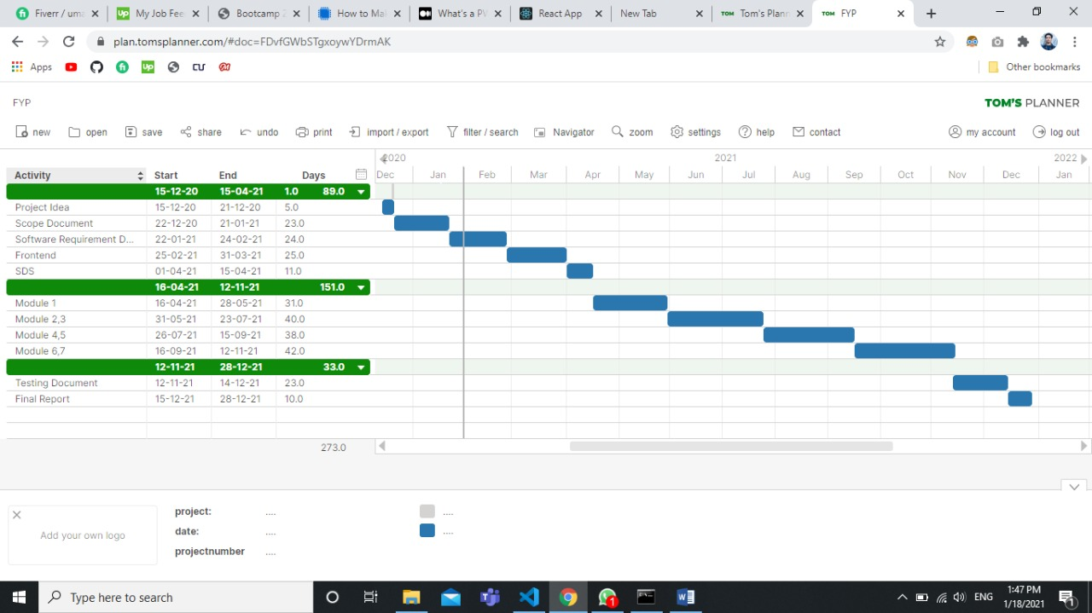

Figure 1: Gantt Chart

# Mockups

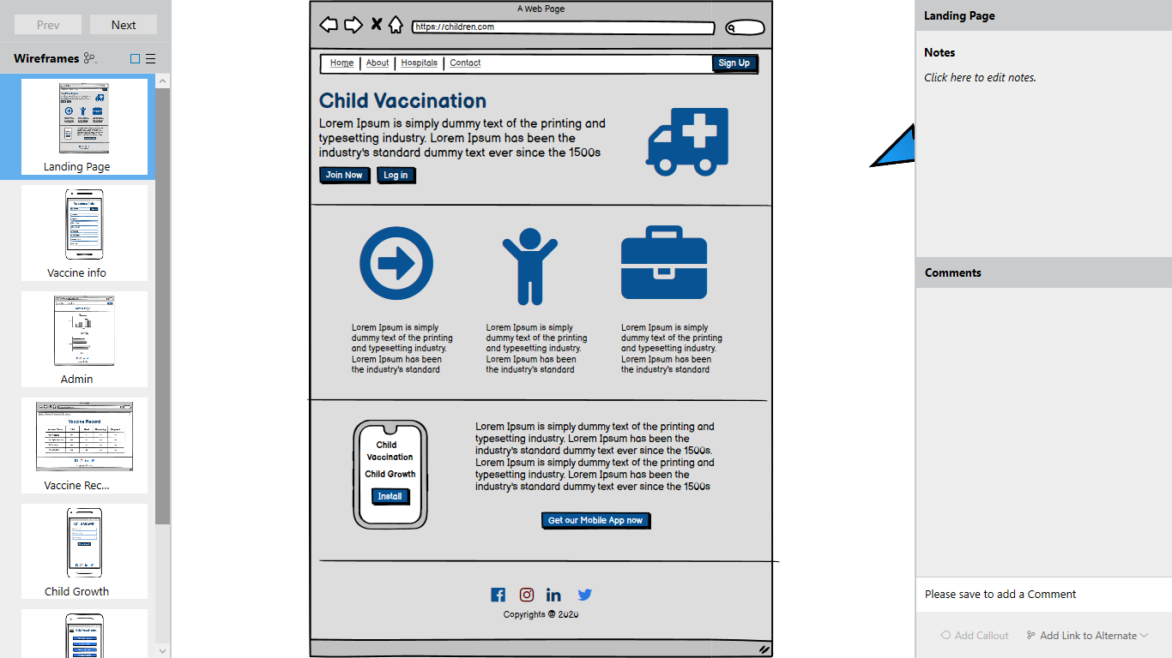

Figure 2: Hospital management mock

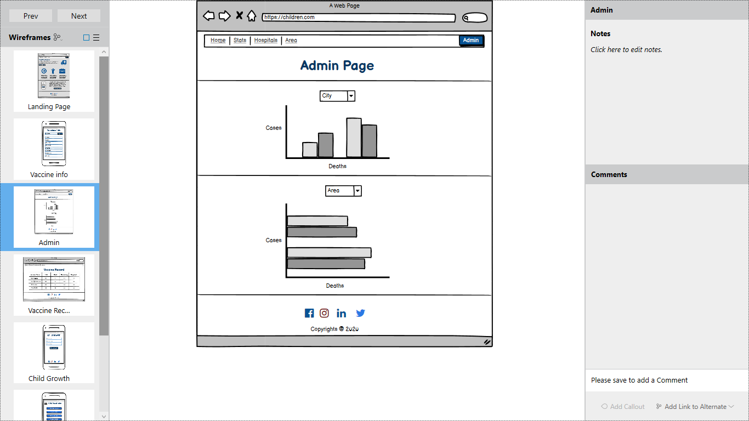

Figure 3: Admin Panel Mock

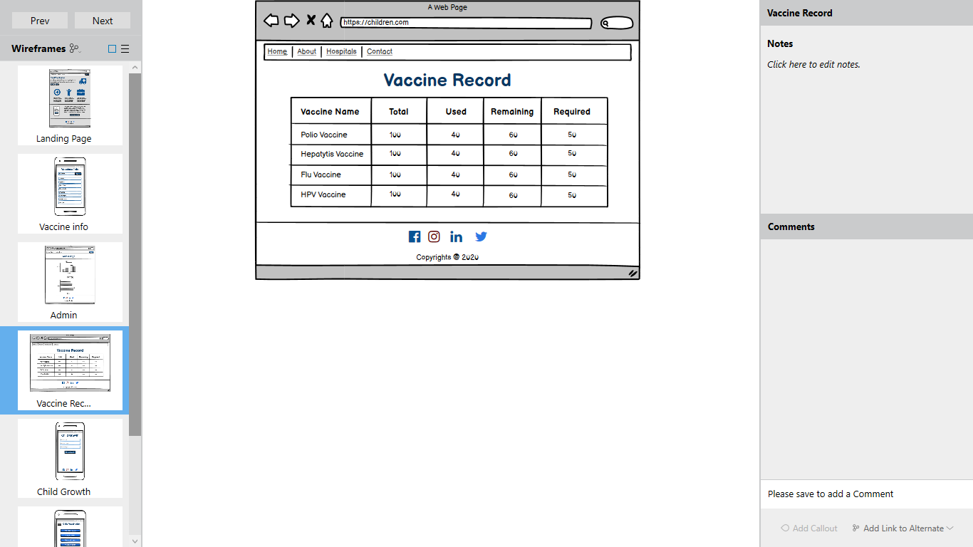

Figure 4:Vaccination management mock

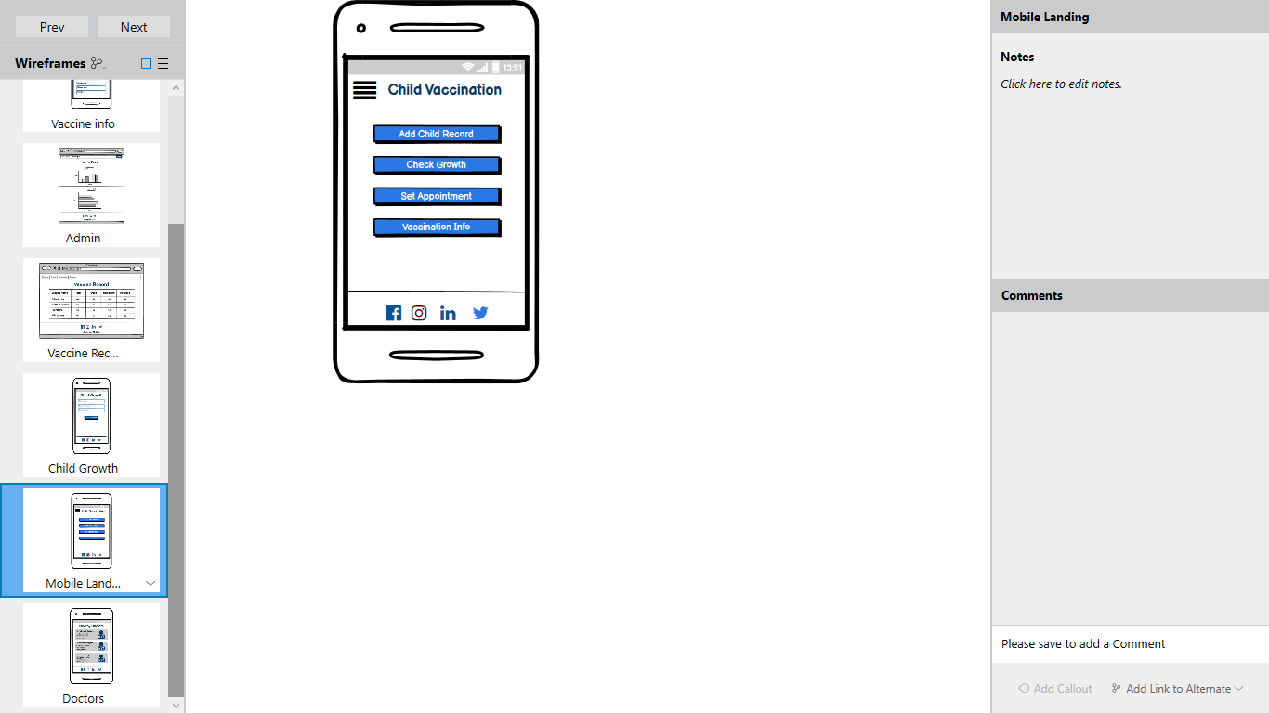

Figure 5:Child Growth mock

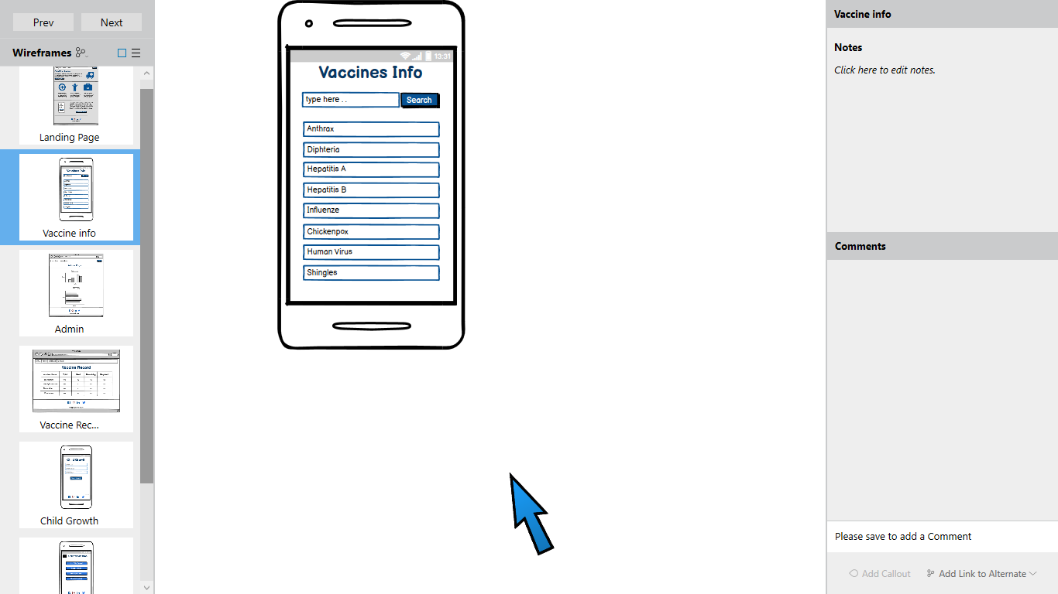

Figure 6: Data visual mock

# Conclusion

Eradication of this problem is very important as it not good for our health. Also, it is a reason for shame in front of the whole world that we are one of the two countries which still have a polio problem. Many children die because of it, yearly. Lack of infrastructure, lack of system, and lack of knowledge are killing those children which is a big pain for the parents. We believe that this system will help the authorities to track and keep the record of the children. Also, it will help parents to know about their child's growth so that they can take measures for their proper growth. This system will also help to reduce the negligence of health workers as their records will be kept in the system. It is very important to predict the future possibilities as we have seen in Covid-19 that prediction of possible cases helped the authorities to control the virus

# References

|  |  |
| --- | --- |
| [1] | unicef, "Unicef," January 2021. [Online]. Available: https://www.unicef.org/pakistan/health. [Accessed 15 Januray 2021]. |
| [2] | W. bank, "https://data.worldbank.org/indicator/SH.DYN.MORT?locations=PK," 2020. [Online]. |
| [3] | WHO, 2020. [Online]. Available: http://www.emro.who.int/pak/programmes/expanded-programme-on-immunization.html#:~:text=The%20Expanded%20Programme%20on%20Immunization,%2C%20pertussis%2C%20tetanus%20and%20measles.. |
| [4] | F. Post. [Online]. Available: https://reliefweb.int/report/pakistan/two-more-children-die-malnutrition#:~:text=According%20to%20the%20health%20department,facilities%20in%20the%20remote%20region.. |
| [5] | IIS, 2020. [Online]. Available: https://www.cdc.gov/vaccines/programs/iis/index.html. |

# Plagiarism Report

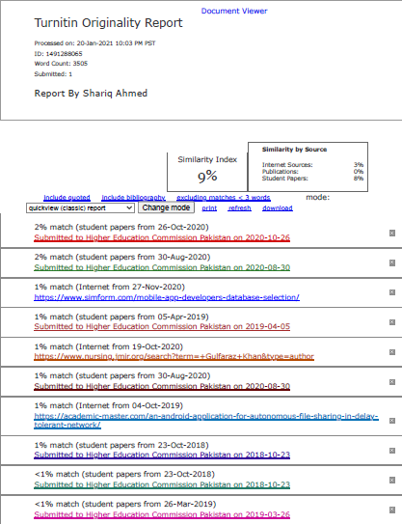

Figure 6: Plagiarism Report